**DAILY ONLINE ACTIVITIES SUMMARY**

|  |  |  |  |  |  |  |  |  |
| --- | --- | --- | --- | --- | --- | --- | --- | --- |
| **Date:** | **07/06/2020** | | | | | **Name:** | **Manish B Shriyan** | |
| **Sem & Sec** | **8th sem B sec** | | | | | **USN:** | **4AL16CS131** | |
| **Online Test Summary** | | | | | | | | |
| **Subject** | | **No test conducted** | | | | | | |
| **Max. Marks** | | **--** | | **Score** | | | **--** | |
| **Certification Course Summary** | | | | | | | | |
| **Course** | **Getting Started with AWS Security, Identity, and Compliance** | | | | | | | |
| **Certificate Provider** | | | **AWS** | | **Duration** | | | **3 Hours** |
| **Coding Challenges** | | | | | | | | |
| **Problem Statement:**  **C Program to convert Decimal to Binary** | | | | | | | | |
| **Status: Solved** | | | | | | | | |
| **Uploaded the report in Github** | | | | | **Uploaded** | | | |
| **If yes Repository name** | | | | | **ManishShriyan** | | | |
| **Uploaded the report in slack** | | | | | **Yes** | | | |

Online Test Details:

---

Certification Course Details:

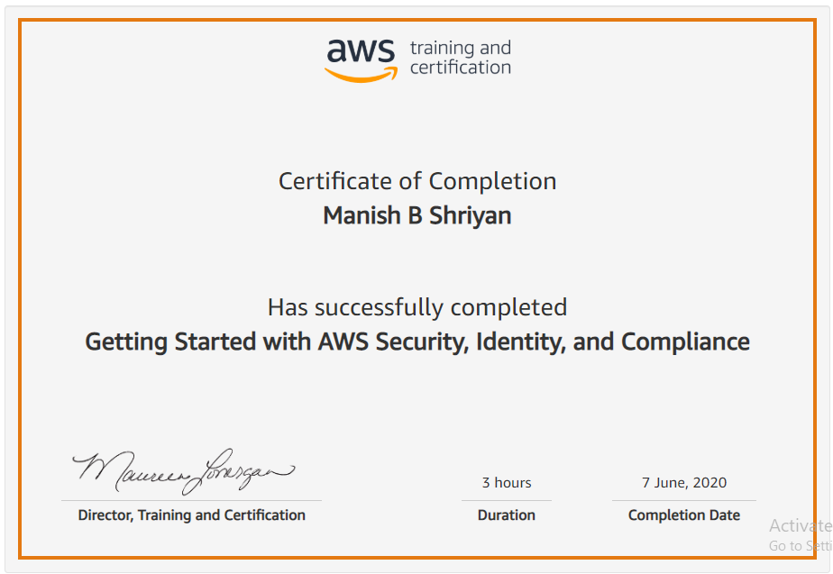

Coding Challenges Details:

|  |
| --- |
|  |
|  |  |
|  |  |
|  |  |
|  |  |
|  |  |
|  |  |
|  |  |
|  |  |
|  |  |
|  |  |

1. #include<stdio.h>
2. #include<stdlib.h>
3. **int** main(){
4. **int** a[10],n,i;
5. system ("cls");
6. printf("Enter the number to convert: ");
7. scanf("%d",&n);
8. **for**(i=0;n>0;i++)
9. {
10. a[i]=n%2;
11. n=n/2;
12. }
13. printf("\nBinary of Given Number is=");
14. **for**(i=i-1;i>=0;i--)
15. {
16. printf("%d",a[i]);
17. }
18. **return** 0;
19. }